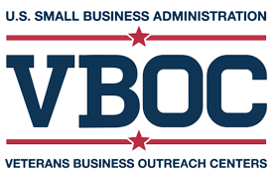

Our Team

Marco Capaldi, AFC
Program Director

Bianca Suchite
Program Coordinator
For more information contact:
Marco Capaldi
VBOC Director, Region I
132 George M. Cohan Blvd. Providence, RI 02903
401-427-6536 (W) 401-447-9227 (C)
MCapaldi@cweonline.org

Visit our website to see
how we can help:
www.vbocnewengland.org

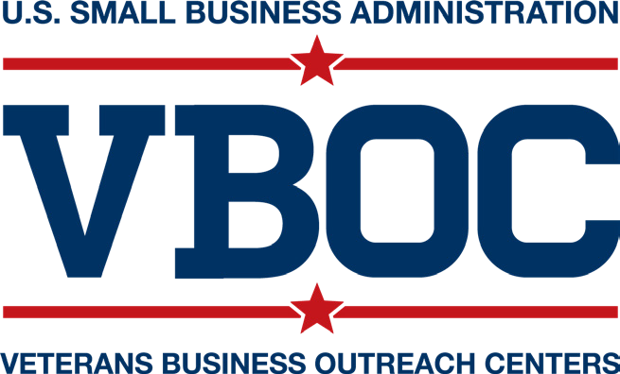

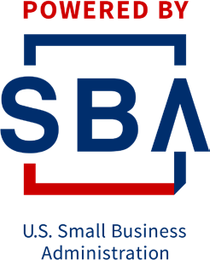

www.sba.gov/offices/headquarters/ovbd
Funded in part through a Cooperative Agreement with the U.S. Small Business Administration

Empowering Veteran Entrepreneurship from Transition to Small Business Success

Serving New England
RI, MA, CT, ME, NH, VT

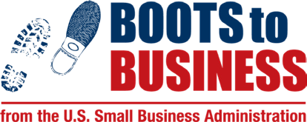

SERVING VETERANS THROUGHOUT NEW ENGLAND
The Veterans Business Outreach Center (VBOC) of New England provides entrepreneurial development services such as business training, counseling, mentoring, and referrals at no cost for eligible veterans owning and considering starting a business. Training opportunities, tailored counseling and mentoring are available in-person and online. The VBOC of New England is operated by the Center for Women & Enterprise.

The Center for Women & Enterprise is a nationally known nonprofit organization dedicated to helping people start and grow their businesses. CWE has worked with more than 46,000 Massachusetts, Rhode Island, New Hampshire and Vermont entrepreneurs since 1995. CWE also operates the Veterans Business Outreach Center of New England (VBOC of NE) that focuses on assisting veterans, active duty service members and their families with starting and growing their business.

HELPING YOU SUCCEED
Arsenal - VBOC Trifold - DRAFT - 5.22.18 (DH).indd 2
The Veterans Business Outreach Center (VBOC) program is a one-stop shop for transitioning service members, veterans, and military spouses looking to start, purchase, or grow a business.
Counseling Services:
- Developing a Business Plan
- Generating Financial Projections
- Buying or Selling a Business
- Expanding a Business
- Creating a Marketing Strategy
- Managing Finances and Analyzing Costs
- Identifying Sources of Capital
- Business Growth Strategies
- Procuring Government Contracts
- Earning Business Certifications

BUSINESS TOOLS AND RESOURCE REFERRALS

- Connection to mentors
- Referrals to other partners and programs
- Preparation to engage SBA lending institutions
- Access to market research databases
- Application assistance for federal and state contracting certification programs

Boots to Business is the entrepreneurship track of the Department of Defense’s Transitions Assistance Program offered on military installations worldwide.

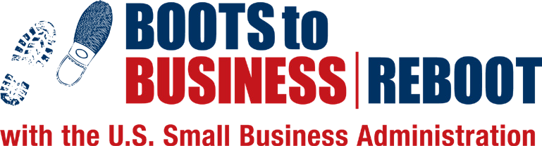

Boots to Business Reboot is an extension of Boots to Business, delivering the same information and benefits to veterans, members of the National Guard and Reserves, and military spouses in a more accessible format.

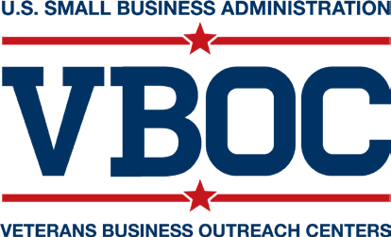

8/6/18 2:35 PM

